Lecture 2: Response analysis and MIFIRA
Response analysis, responses to food insecurity, and MIFIRA

- Responses to food insecurity
- Response analysis
- Benefits and costs of different transfers
- Definitions
- Market Information and Food Insecurity Response Analysis (MIFIRA)
- Scales of analysis

Readings:
- Barrett, C.B., Bell, R., Lentz, E.C. and Maxwell, D.G. 2009. “Market Information and Food Insecurity Response Analysis.” Food Security 1:151‐168.
doi:10.1007/s12571-009-0021-3
http://www.springerlink.com/content/20t80w3656428335/

Supplementary Readings
- Selections from World Food Programme (2009) Emergency Food Security Assessment Handbook. Annexes 4 and 5. Pp. 255-269.
http://documents.wfp.org/stellent/groups/public/documents/manual_guide_proced/wfp203245.pdf
- Harvey, P. (2007) “Cash – based responses in emergencies.” London: Overseas Development Institute HPG Report No. 24.
doi:10.1111/j.1759-5436.2007.tb00383.x
www.odi.org.uk/resources/docs/265.pdf
- Michelson, H., E.C. Lentz, R. Mulwa, M. Morey, L. Cramer, M. McGlinchy and C. B. Barrett, “Cash, Food or Vouchers in Urban and Rural Kenya? An Application of the Market Information and Food Insecurity Response Analysis Framework,” Food Security, forthcoming. http://dyson.cornell.edu/faculty_sites/cbb2/Papers/20110331MIFIRADraft.pdf
- Mude, A. G., R. Ouma, and E.C. Lentz, “Responding to Food Insecurity: Employing the Marking Information and Food Insecurity Response Analysis framework in rural Northern Kenya.” Journal of Development Studies, forthcoming. http://dyson.cornell.edu/faculty_sites/cbb2/MIFIRA/apps/
- Hill, E., J. Upton, A. Xavier, 2011. “Local and Regional Procurement in Uganda: Lessons learned from a pilot study of the Market Information and Food Insecurity Response Analysis (MIFIRA) framework. July. Draft. http://dyson.cornell.edu/faculty_sites/cbb2/MIFIRA/apps/

Responses to food insecurity

The political economy of aid distributions is changing. For a long time, the US, Canada, and other donors shipped food aid. Now, there are many transfer choices when responding to food insecurity, including cash and vouchers, food procured locally and regionally, and transoceanic food aid. Several factors have resulted in this growing trend away from exclusive donations of in-kind transoceanic food aid. Increasing donor flexibility, such as the European Commission’s untying of aid and recent appropriations for local and regional procurement of food aid in the 2008 US Farm Bill, has enabled agencies to consider alternatives to tied, in-kind food aid. Further, a focus on respondent-driven needs, rather than donor-driven availability, has contributed to a growing momentum for non in-kind transfers (see Barrett et al. 2009 for more detail).

A fundamental question is how to choose from among these different types of transfers. The increasing availability of choices means that agencies need better assistance in understanding response analysis. Many of the costs and benefits of the various transfer options are contingent upon markets.

Response Analysis
Most agencies and donors now agree that responses ought to be tailored to context. In order to do so, agencies need better decision-making tools to help guide both emergency response planning and programs that help protect consumption and assets in situations of chronic food insecurity. Between the needs assessment and response planning function exists an equally important – but commonly neglected – step of analyzing the likely impact of alternative responses, an aspect of the programming cycle that is coming to be known as “response analysis.”

MIFIRA is one approach to response analysis. Comprised of two framing questions and associated subquestions, MIFIRA is designed to assess market capacity to respond to food insecurity.

Figure 1 is a standard way of situating response analysis within the programming cycle. Yet, various processes that must take place roughly simultaneously in the face of vulnerability and shocks that potentially cause food security crises. These processes can be summarized as information gathering tasks, planning and analysis tasks, and program implementation tasks. Thus Figure 2 is a more realistic, albeit more complex, representation. Several points about Figure 2 merit mention. First, although the programming cycle is often depicted as a sequence of tasks, as in Figure 1, in reality information collection, planning and analysis, and implementation must take place largely simultaneously. For example, contingency planning is informed by the baseline vulnerability assessment, but cannot wait until the baseline analysis is completed. The mitigation of shocks and rapid response likewise cannot wait until all needs are assessed. And so on. Finally, unanticipated, acute “shocks” may trigger a response analysis, but just as important is response analysis for predictable or chronic needs.

Figure 1: Situating response analysis within the programming cycle
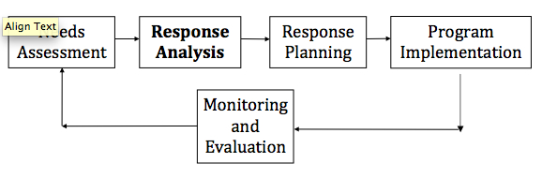

Second, response analysis and response planning, when thought of at all, are typically assumed to follow needs assessment. However, some response analysis can – indeed, must – precede emergency needs assessment in order to facilitate rapid decision making. A complete response analysis cannot be finalized until needs are clear. But if analysis does not begin until needs are assessed, response delays can prove fatal.

Needs assessments often provide critical context. The best needs assessments identify livelihoods approaches, consumption and expenditure patterns, access to services, and which populations are relatively more at-risk. Many needs assessments carefully consider gender, and may capture gender-disaggregated differences in consumption and expenditure patterns as well as resource control and decision-making powers. Response analysis too can mainstream gender by tracking market access and participation by gender. Understanding gender-based resource control and how it may differ by transfer type, volume, or distribution site should inform programming choices.

Third, monitoring, although depicted as one of a sequence of tasks, should pervade the program cycle. This includes the monitoring of early warning indicators, program inputs and expected impacts, as well as unintended impacts on markets or other subpopulations. Ongoing monitoring must identify the evolving impacts of program intervention choices so as to inform appropriate programming adjustments.

Fourth, although depicted in Figure 2 as if triggered by a specific incident or shock at a particular point in time, many food crises do not have such time-specific causes. For example, chronic food insecurity situations typically have diffuse causality. This temporal indeterminacy underscores the necessarily cyclical nature of the planning, analysis, implementation and monitoring process.

Figure 2. The Programming Cycle:
Information Gathering, Planning and Analysis, and Implementation 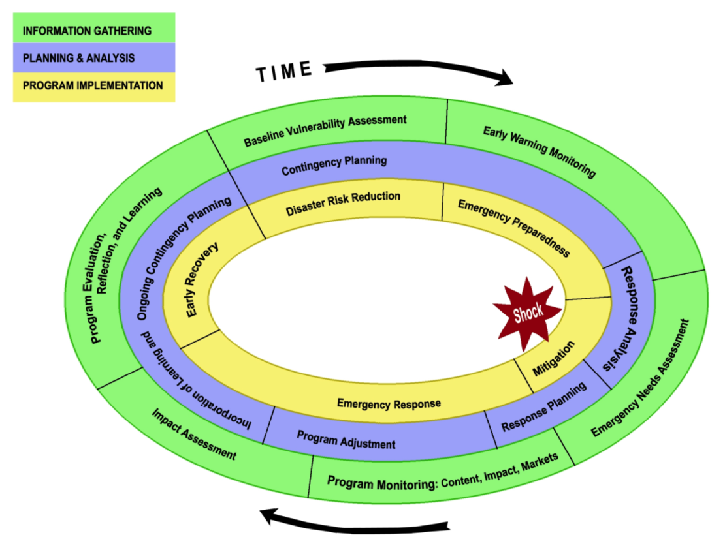
Source: Barrett et al. 2009.

Finally, while Figure 2 specifically represents an emergency programming cycle, a similar programming cycle can be readily adapted to address chronic food insecurity due to recurring household-level food access shortfalls. For example, such a cycle would underpin social protection programs, designed to respond to chronic food insecurity and poverty. The primary differences between emergency and non-emergency programming are (i) the time frames within which analysts must operate, (ii) the greater possibility in emergency situations for significant disruption of conditions from those present during baseline assessments – e.g., floods or earthquakes necessitating emergency response may have also destroyed critical food marketing infrastructure –(iii) a less specific shock or causal factor in non-emergency situations and (iv) a greater focus in non-emergency programming on alleviating underlying causes of food insecurity.

The last point especially underscores that response analysis must be informed by both good baseline analysis – in particular, knowledge of how local and regional food markets work and identification of reliable data sources – and early warning information – e.g., market indicators such as prices – and must gauge the requirements for a response before needs assessments are completed. This simultaneity between response analysis and needs assessment reinforces the iterative nature of programming cycles; these are not linear, once-and-for-all decision-making processes.
Further, MIFIRA does NOT address two crucial questions to which an analyst needs at least provisional answers before she commences MIFIRA:
- Who is food insecure? How many people fall into that subpopulation and where are they?
- What does this subpopulation most need and how much of it do they need? For example, if an effort is directed primarily at severely malnourished children who have nothing, they may need therapeutic foods enriched with micronutrients to replace a complete (missing) diet. By contrast, if the intervention is in response to a disaster (e.g., earthquake, flooding) that has disrupted usual food marketing channels and livelihoods, there may not be a need for anything beyond modest volumes of basic commodities.
Within the programming cycle, these two questions are the domain of needs assessment. There is a massive operational literature on needs assessment. Perhaps the best sources of information are the IFRC (e.g., Disaster Emergency Needs Assessment, June 2000, http://www.ifrc.org/Docs/pubs/disasters/resources/corner/dp-manual/Disemnas.pdf) and, especially on food, the WFP’s Emergency Food Security Assessment Handbook (2009).

Why the form of transfers matter:
Getting the form of transfer right helps livelihoods. Households may sell food aid - often at a deep discount - to purchase what they need. Yet, when markets are not functioning, cash is of limited value. Further, getting the transfer right can minimize harms to markets. Whether a market will be harmed or is as risk of being harmed depends on a number of factors including: the total amount of aid distributed; whether the transfers meet household needs / household demand; the season of deliveries; the type of transfer; and the functioning of local market(s)

Below, we outline the differences between different forms of transfers.

Why cash? Why not cash? … Why food? Why not food?

Food transfers generally recommended when: | Cash transfers generally recommended when:
1.Food intake is prioritized for nutritional purposes (including targeted feeding and micronutrient objectives)  2.Markets do not function well  3.Markets are distant, or during the lean season  4.Inflationary risks are a significant concern  5.Security conditions permit (i.e., food commodities are highly visible)  6.Cash transfer systems do not exist  7.Cost savings is sought through individual / household targeting | 1.Overall humanitarian need, as well as choice and flexibility are prioritized  2.Markets function well  3.Markets are nearby, or during the peak, post-harvest season  4.Production disincentives due to food aid delivery are a significant concern  5.Security conditions permit (i.e., cash is less visible but offers greater incentive for theft)  6.Cash transfer systems exist  7.Cost saving is sought through lower logistical and management overhead
Source: Barrett et al. 2009.

Why transoceanic food aid? Why locally and regionally procured food?
Locally procured foods are bought in the country where distributions will occur, while regionally procured foods are bought in a neighboring country or in a country within the same continent.

Locally or regionally procured food generally recommended when… | Transoceanically procured food generally recommended when…
Time is of the essence. LRP tends to arrive faster than transoceanic food aid | Concern that procuring food will cause inflationary pressure in source markets
May be able to time deliveries to coincide with lean season, minimizing production disincentives | Concern that traders will default on tenders or will drive up prices in anticipation of agency purchases
Potential for cost savings, especially for bulkier products, such as grains and pulses | Concern that quality and safety standards cannot be met with LRP food
Source: Barrett et al. 2009.

Food Insecurity: Identifying responses
Each transfer choice has benefits and costs and there are tradeoffs across each transfer. Many of the costs and benefits of the various transfer choices are contingent upon markets. Understanding markets’ roles in addressing food security can lead to designing better social transfer schemes in programs. There are, however, important non market considerations as well.

Market analysis is the common denominator to most of the considerations raised, both by the literature that explores the choice between cash (or cash-equivalent) and food transfers, and by the literature on local and regional purchases of food aid. One needs to know how well the intended beneficiaries interact with local markets and how well those markets respond to external interventions.

The following are some important non-market factors that can also impact a response analysis. We do not cover them here, as incorporating them into a response analysis requires specialized knowledge (e.g., assessing food safety) or depends on NGO objectives and resources.
- Security and external diversion of resources
- Gender and anti-social spending
- Malnutrition and micronutrient deficiencies
- Assessing food safety and related standards to ensure quality
- Capacity of agency country offices to implement different kinds of programs

Defining markets
Before describing MIFIRA in more detail, we provide some basic definitions. Food markets include everything from grocery stores to village shops to weekly bazaars to neighbors selling or bartering with one another.

- Markets are composed of:
  - Buyers of particular goods
  - Sellers of those same goods
  - Institutions and infrastructure
  - Others behind the scenes: importers, processors, storage owners, wholesalers, credit suppliers, government officials and policy makers
• Relative functioning of a market depends on:
  - Number, size and independence of buyers and sellers
  - Formation of prices
  - Availability of information on prices and costs
  - Ease of entry and exit
• Relative functioning of a market system depends on:
  - Reliability of contract enforcement
  - Integration across markets
  - Institutional framework (infrastructure, government policies, etc.)

To summarize, the types of markets that a household can access can be quite diverse, and analysis should incorporate more than formal shops.

A marketshed is the geographical area and population that has actual or potential trade relationships with a market center. Marketsheds are composed of a network of markets and market flows within an area. Often, one market is dominant in size and capacity.

Other helpful vocabulary includes the following:

FEWS NET commodity chain vocabulary:
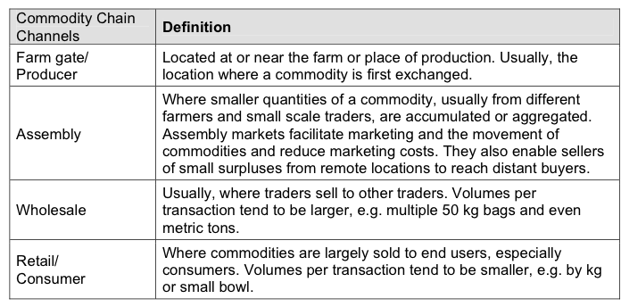Source: FEWS NET (2008) Market Analysis and Assessment. Lesson 1, p. 5.

FEWS NET Key Components of a Market Relation:
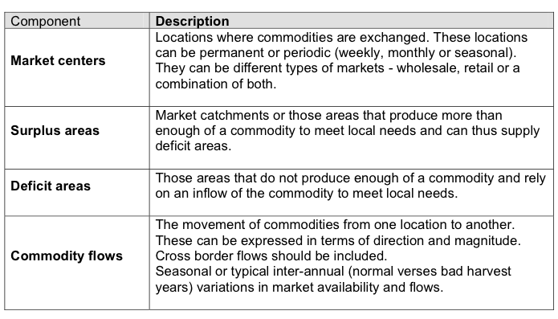

Source: FEWS NET (2008) Market Analysis and Assessment. Lesson 1, p. 12.

Market-based response analysis: MIFIRA

The objective of MIFIRA is to assess the functioning of food markets used by target food insecure population(s) and identify the likely behavioral responses of key market participants – such as traders, importers, households, government, and NGOs – so as to determine the food assistance intervention most appropriate for the circumstances.

Response analysis for food insecurity must first identify how local supply and prices in the target distribution market will likely respond to increased demand following an injection of cash into households or to increased supply from local distribution of donated food. In essence, are markets functioning? If food aid appears necessary, the second step examines how prices will likely respond to food procurement in local or regional markets and how producer prices may be impacted by food aid distribution in a target recipient community. This step addresses the question, is there sufficient food available nearby to fill the gap?

MIFIRA Framework
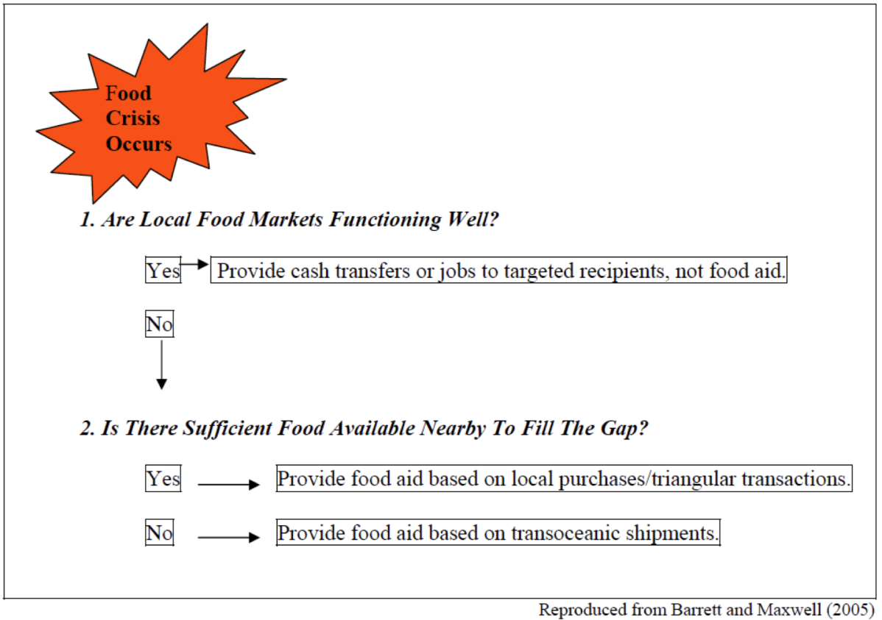

Question 1. Are local markets functioning well? The objective in answering this question is to establish whether cash transfers offer a feasible, effective response for addressing a food security crisis. If so, are they appropriate for everyone or only for some sub-populations? Will cash transfers be sufficient, or effective only up to some limit beyond which complementary food aid deliveries will be required?

Question one must be further broken down to become operationalizable. We find that the minimum manageable disaggregation consists of the following five sub-questions:

1a. Are food insecure households well connected to local markets?
1b. How will local demand respond to transfers?
1c. How much additional food will traders supply at or near current costs?
1d. Do local food traders behave competitively?
1e. Do food insecure households have a preference over the form/mix of aid they receive?

Indicators point in the direction of relying on local market-based mechanisms to expand food access in the following circumstances: (1) if food insecure households routinely participate in local markets for staple foods (1a); (2) targeting needy households is feasible or the amount of aid given to each household is low relative to their total purchasing power, thereby minimizing market distortions associated targeting errors (1b); (3) traders can readily expand deliveries into the local market at or near current costs so that the inverse price elasticity of supply (the percentage change in supplier cost for a percentage increase in supply) is low (1c); (4) markets are reasonably competitive so that powerful intermediaries cannot simply mark up prices to extract the transfers provided to food insecure households (1d); and, (5) target households indeed want cash (1e). Conversely, if target households do not routinely participate in food markets (1a) or clearly prefer food to cash (1e), supply is quite price inelastic, especially if demand response would be strong (1b and 1c), or traders can exert real market power (1d), then the analysis favors greater reliance on importing food through noncommercial channels. Intermediate answers will be common, indicating either limited capacity to use markets, or capacity to use markets only for certain commodities or for particular target subpopulations. The disaggregated decision tree is reflected below.

First Stage of Market Information and Food Insecurity Response Analysis, Addressing the Question “Are local markets functioning well?”
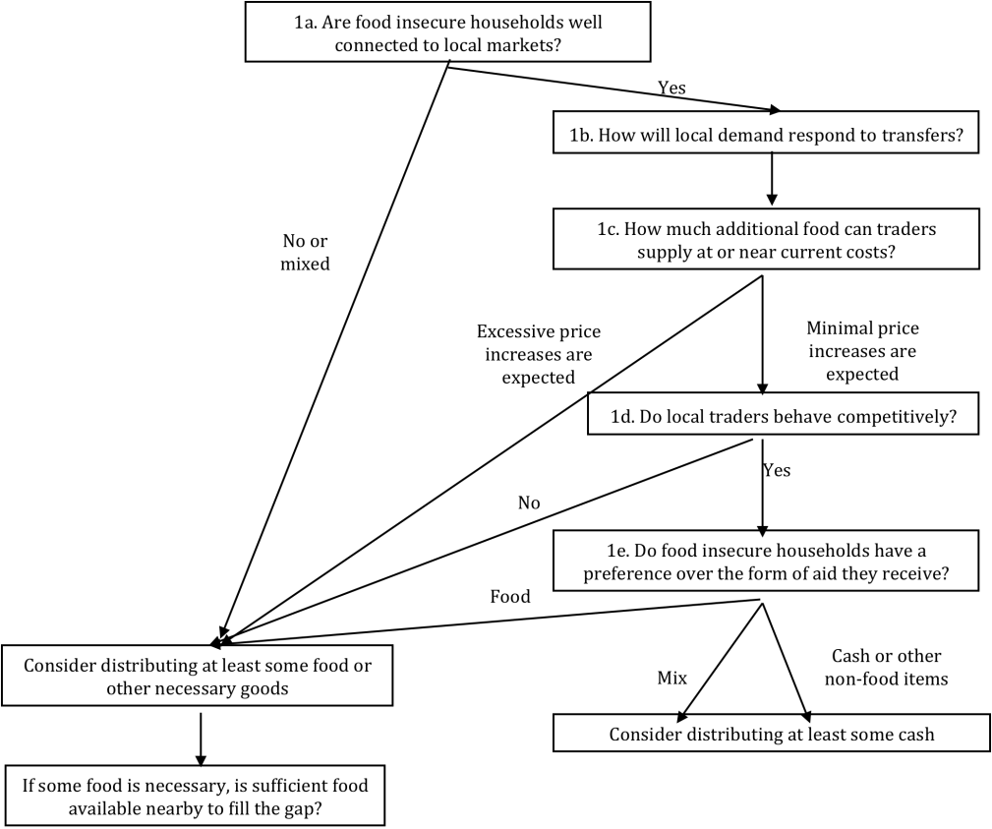
Source: Barrett et al. 2009.

Unless markets are truly failing, as in the case of hyperinflation, or when logistical or financial bottlenecks limit additional throughput capacity to relatively remote and inaccessible locations, or when one or a small number of traders has considerable market power over pricing, a mixture of cash and food is commonly desirable, with cash targeted to those with relatively good market access under more competitive conditions, and food to those with relatively poor market access under less competitive conditions. While this can be administratively complex, and there are few good rules of thumb available regarding appropriate mixtures of cash and food, the inherent flexibility of mixtures means that agencies can adjust the mixture as market conditions improve or deteriorate. As mentioned earlier, ongoing monitoring of markets and of recipients’ and communities’ needs is necessary. Once-and-for-all response analysis is typically inadvisable. In the face of poorly functioning markets and limited supply, flexibility can improve livelihoods by offering households greater choice combined with some food security while enhancing market functioning.

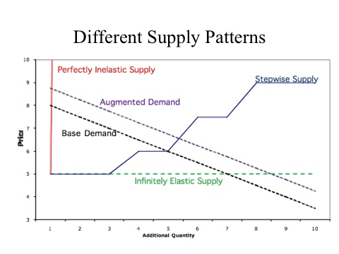

One goal of the sub-questions is to establish an estimated shift in the aggregate demand curve due to a prospective injection of cash and to determine the slope of the supply curve. In cases where the supply for food is infinitely elastic, an increase in demand (the shifting of the demand curve from left to right, indicating an increase in quantity demanded) will not result in price increases. In highly inelastic supply situations (e.g., a market is cut-off from resuppliers), any increase in demand will result in price increases. In step-wise supply functions, demand can increase somewhat before prices increase (e.g., trader faces the same cost structure when she brings a few more kilograms of food to a market but if she were to bring many more kilograms she would face a higher cost structure because she would need to find more expensive transportation, labor, etc.). In later lectures, we estimate how much demand may change due to a transfer and how much suppliers can provide before prices increase.

Cumulatively, the answers to sub-questions 1a-1e equip analysts to come up with a balanced, evidence-based answer to the first fundamental question of response analysis: are local food markets functioning well? If they are, then cash-based responses are generally preferable. In that case, analysts can typically stop after this section of the response analysis as there is no need to explore food sourcing options. If, however, food markets are not functioning well, then food deliveries are typically necessary and one needs to tackle the second fundamental question of the MIFIRA framework.

Question 2. Is there sufficient food available nearby to fill the gap? The objective in answering this question is to establish from where an organization should procure food to distribute into the target delivery market so as to provide the most effective response, taking into consideration cultural and nutritional appropriateness, cost, food safety, timeliness and generalized market effects. The historical default in food aid has been transoceanic shipment from donor countries. However, food aid procurement modalities are changing quickly. In 2008, the United Nations World Food Programme procured 2.8 million metric tons of food - 78% of its total food assistance - from 85 countries, 73 of which were considered developing (http://one.wfp.org/operations/Procurement/food_pro_map_08/fpm_popup/fpm_popup.html). Furthermore, local or regional purchases are increasingly an option with some donor or private resources.

As with the first core question, this second question can be broken into three related sub-questions:

2a. Where are viable prospective source markets?
2b. Will agency purchases drive up food prices excessively in source markets?
2c. Will local or regional purchases affect producer prices differently than transoceanic shipments?

If some food aid deliveries are deemed necessary per the decision tree of question 1, question 2 helps the analyst identify which possible local or regional market sources would likely provide the most cost effective and timely supply, while minimizing harmful price effects to consumers in source markets and to producers in the target delivery market(s). Once candidate markets have been identified based on available supply, comparing transport capacities, inter-country and intra-country regulations on moving food, and availability of traders regularly engaged in moving large quantities of food can further narrow the search for the best source market (2a). Among these ideal source markets, the tools in sections 1b and 1d enable analysts to examine the potential impact of purchasing food on the source market, in order to limit prospective harm to non-beneficiaries who buy food in that same market. Intuitively, the smaller the purchase relative to the overall market size, the smaller the potential unintended price impact (2b). Comparing how LRP food aid may impact producer prices differently than transoceanic food aid is the final step in identifying the best source of food aid. Delivering appropriate forms of food aid to beneficiaries during a lean season or when prices are abnormally high will limit harm to domestic producers (2c).

When a marketing hub can provide food readily and cost effectively while facing minimal delivery delays (2a), purchasing from this marketing hub will have little impact on the hub’s prices (2b), and LRP will arrive at a more seasonally appropriate time than transoceanic shipments. Also,if the LRP food is more culturally appropriate (2c), then LRP will typically be the preferred procurement mode for food aid. Conversely, when local or regional marketing hubs do not have adequate supply or will face long delays in moving the food to the domestic distribution area (2a), purchasing from these hubs will significantly drive up prices, harming source-market consumers (2b). Also, if deliveries of LRP food are more likely than transoceanic shipments to coincide with or follow soon after a harvest, or food available in local or regional markets is not culturally appropriate, then transoceanic shipments are preferred. This disaggregated decision tree is reflected below.

Second Stage of Market Information and Food Insecurity Response Analysis, Addressing the Question “Is there sufficient food available nearby to fill the gap?
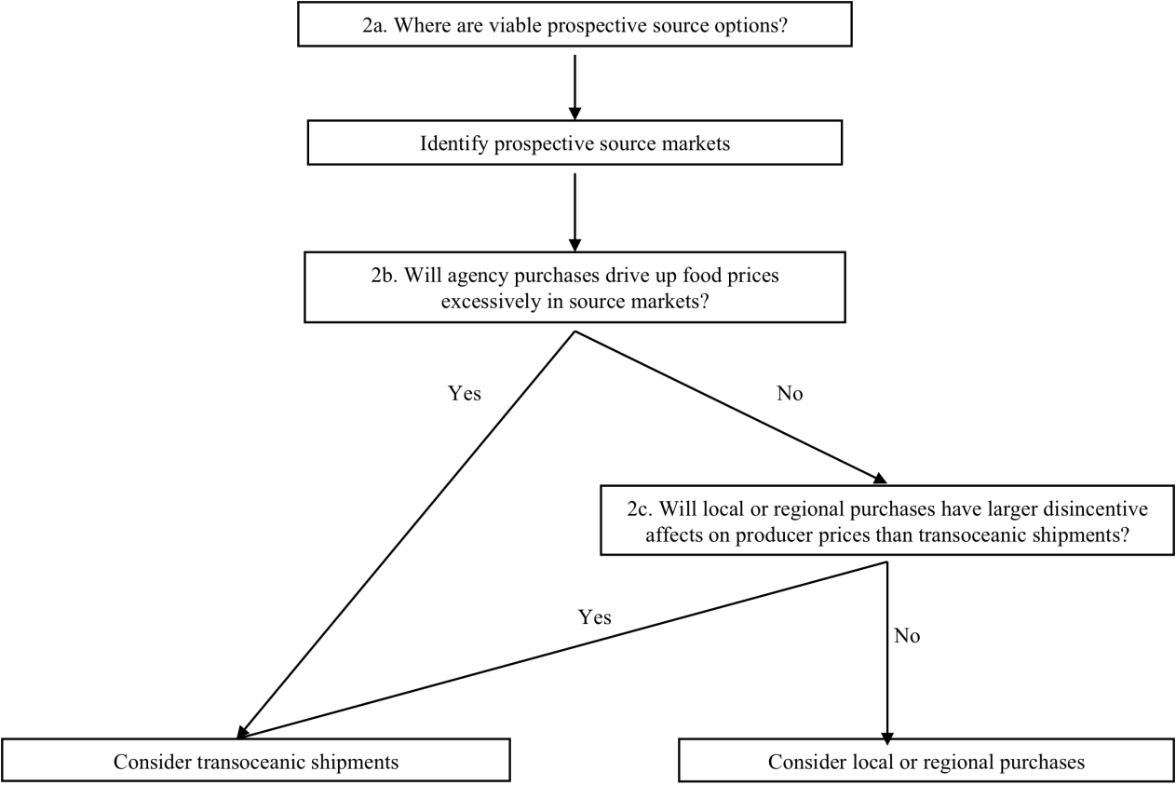
Source: Barrett et al. 2009.

As with question 1, question 2 will not always yield unequivocal answers. Analysts need to weigh the relative importance of each aspect in the particular contexts they face. For example, during rapid onset emergencies, the speed of delivery is especially important. This relates back to contingency planning, prepositioning and early warning, all-important programming concerns, but ones not directly addressed by MIFIRA. During slower onset or chronic crises, ensuring that domestic producers are not harmed in a way that could render them more susceptible to future crises may be a top priority. Similarly, if an entire region is at risk, the desire to avoid spreading price increases to nearby, vulnerable marketing hubs may point to transoceanic shipments. Finally, when done correctly, food purchased locally or regionally could have the added benefit of supporting local and regional producers and traders. This support could also improve market ties, possibly lessening the need for later external interventions in the form of food shipments.

Different market assessments for response may require varying levels of rigor. For example, interventions in new areas or with new resources, large scale interventions, and interventions in remote areas all could benefit from a more in-depth analysis than interventions responding to a rapid-onset crisis or interventions where baseline data exist. The need for and feasibility of complex analyses will depend on a number of different factors:
- Data availability
- Capacity
- Time-frame
- Resources available
- Type of emergency
- Expected size of intervention

It is nearly impossible to anticipate every aspect of market failures or weak market functioning. Therefore, team members may have to expand or revise analytical tools and surveys in order to examine the current situation.

Scales of analysis
Some MIFIRA questions must be answered both at the national and regional (macro) levels and at local marketshed (meso) level, while others must be answered at the household (micro) level. One approach to implementing the framework is to consider the data collection and analysis processes at these three distinct – micro, meso, and macro– scales of analysis. The existence of multiple scales of analysis raises the possibility of analysts and agencies involved in the response to a given food insecurity context to divide their labor according to comparative advantage.

District governments and NGOs typically have a comparative advantage in collecting primary data at the household (micro) level because of their field presence and relatively more nuanced understanding of the communities in which they work. Local agencies sometimes also have a comparative advantage in collecting and analyzing primary data at the meso-level linking the community’s marketshed to the broader national and regional economies. However, understanding markets at the meso-level often requires more economic analysis and better access to a mixture of primary and secondary data than does understanding household-level relations to markets. Thus meso-level data collection and analyses are sometimes beyond the capacity of local governments and NGOs and are better handled by national governments, donors or regional organizations. At the macro level, understanding national and regional markets typically requires ongoing monitoring and analysis of secondary data, often complemented with key informant interviews. These tasks commonly require staff and skills beyond the reach of smaller local governments and NGOs and fit with national government, donor and regional organization mandates. The figure below depicts a typical assignment of MIFIRA market analysis questions to the most relevant level of analysis, as well as the inherent complementarity of different agencies’ skills, as reflected in the width of the twinned triangles at any given scale of analysis.

Macro-scale analyses examine whether traders are likely to increase supply at reasonable prices (question 1c) and, whether they behave competitively (question 1d). These analyses require information on international and national market prices, production, imports, markets and trade policies, the number and characteristics of major traders, etc. Collecting and analyzing such data is costly. Food security monitoring groups and early warning systems supported by governments, donors, UN agencies, and consortiums of government agencies and NGOs already collect and synthesize much of the relevant macro data such as import parity prices, and whether/how trade policies pose barriers to the timely and affordable commercial import of food. Obtaining key analyses and data from established sources can help agencies avoid reinventing the wheel.

MIFIRA Scales of Analysis
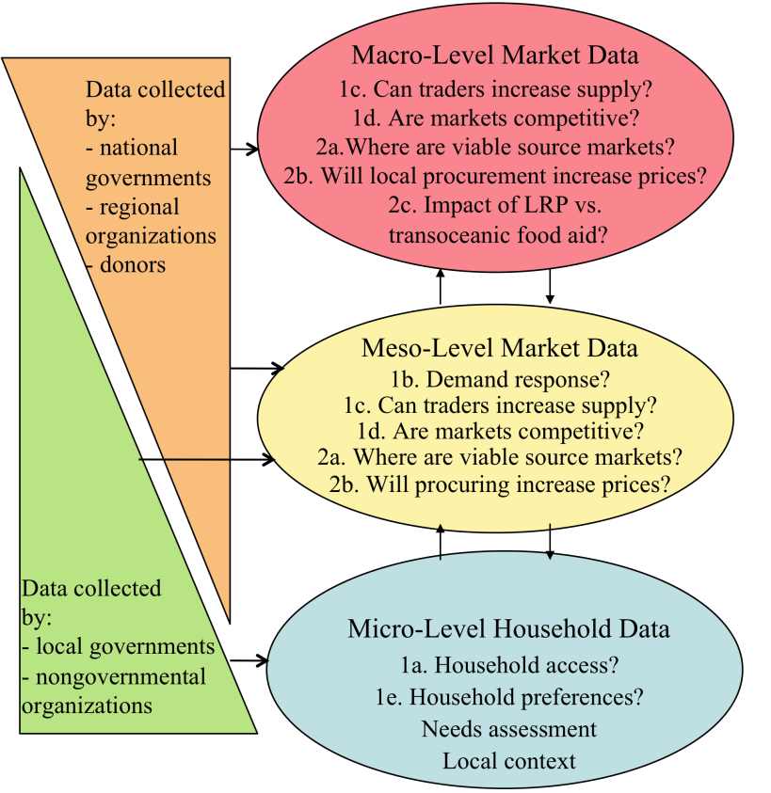
Source: Barrett et al. 2009.

The meso-scale analysis links the marketsheds relied on by targeted food insecure populations to regional and city markets. Smaller traders are typically able to provide quantitative and qualitative data on general market functioning, competition levels, supply chains, volumes and prices in markets, seasonal differences, costs, and any constraints on their trade. But meso-scale data collection and analysis typically needs to be undertaken from scratch.

Meso-scale analyses are extremely important and much less commonly available through existing institutions. Most currently available secondary data sources are highly aggregated. Secondary data tend to be collected from major cities, district capitals, or major market centers and are rarely available for smaller market centers. A critical gap in understanding markets remains in determining the relationship between the macro-scale market assessments that are often readily available (i.e., those based on national or regional trading centers) and smaller markets in an agency’s specific programming areas.

The focus of micro-scale analysis is households’ likely responses to transfers. Generally, some household survey data are available from needs assessments, baseline studies or other related exercises. These data typically provide information on expenditures, income, and consumption, all of which can help in estimating how local demand should respond to transfers (question 1b).

MIFIRA summary
The Market Information and Food Insecurity Response Analysis Framework (MIFIRA) framework has the following objectives, approaches, users, audience, and methodological approach:

Objective
The objective of MIFIRA is to identify the present context of the food markets facing the target food insecure population(s) and the likely behavioral responses of key market participants – such as traders, importers, households, government, and NGOs – so as to identify the resource most appropriate to the circumstances.

Approach
Response analysis is distinct from a needs assessment. MIFIRA identifies a variety of methodological approaches to answering key market analysis questions. Local contexts, data availability, technical capacity, and resources will determine which methodology is most appropriate. Some of these questions need to be answered at both the national and regional levels and local marketshed levels, while others must be answered at the household level.

MIFIRA is context neutral. Asking contextualizing questions can help to give an overview of the current food insecurity and help to focus the analysis. First, questions on consumption patterns and livelihoods will inform the demand for various products in markets and the frequency of market visits (e.g., pastoralists may use markets less frequently and may buy different types of foods than farmers). Second, marketshed mapping identifies the characteristics of markets that may be utilized by recipients and how those markets may have been impacted in the case of an emergency.

A baseline analysis using MIFIRA questions can be updated following an emergency, onset of food insecurity, or change in market situation. In fact, MIFIRA is most effective when it is incorporated into disaster preparedness and planning programs in areas that face recurring crises or chronic food insecurity rather than when implemented for on-off emergencies.

Users
Data needs can be split into primary and secondary sources. Different users may be well suited to different scales (i.e., national scale, marketshed scale, household scale) of the analysis. Field staff are well placed to collect primary data (at the household and marketshed scale) while market analysts and technical staff may be well placed to collect secondary data (at the national and, sometimes, marketshed scale). MIFIRA utilizes much of the technical analyses undertaken by other interested parties, such as government ministries or bureaus, FEWS NET, WFP, vulnerability and assessment committees, etc. Market analysts with field staff support should undertake data synthesis.

Methodological approach
MIFIRA’s methodological approach is grounded in market analysis, using two framing questions (i.e., Question 1. Are local markets functioning well? Question 2. If not, ss there sufficient food available nearby to fill the gap?) and a series of sub-questions related to each framing question.

Resource transfer choices or combinations will make a difference. Cash transfers and vouchers support purchasing power and local markets, quickly. Local procurement to enables the use of local food products and may energize local markets. Both cash and local purchases can strengthen local food chains and support smallholders. Lastly, food aid can provide valuable support to people during combined availability and market failures.

The FAO definition for a marketshed is from http://www.fao.org/economic/esa/seed2d/projects2/marketsseedsdiversity/keyconcepts/en/

